School of Computer Science and Artificial Intelligence
Lab Assignment # 5.2

Program : B. Tech (CSE)
Specialization :
Course Title : AI Assisted coding
Course Code :
Semester II
Academic Session : 2025-2026
Name of Student : Rohan beri
Enrollment No. : 2403A51L09
Batch No. 51
Date :20-01-2026

Task 1: Secure API Usage
Prompt : Generate a simple REST API for user registration.

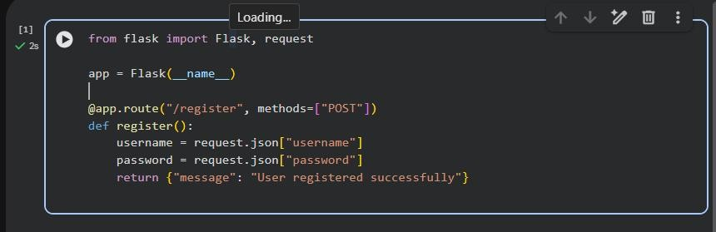

Identified Security Flaws
- No authentication mechanism

- Password stored/used in plain text

- No input validation

- No token-based authentication

- API key handling missing

Corrected Secure Code
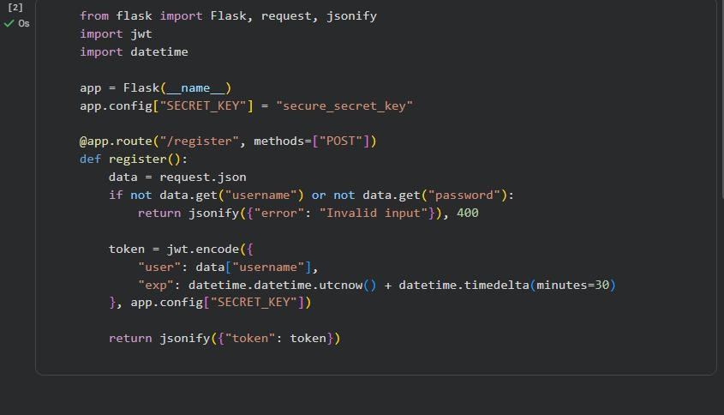

Explanation
- Input validation prevents invalid data

- Token-based authentication improves security
- Secret keys are handled securely
- Avoids insecure coding patterns

Output (Insecure Version):
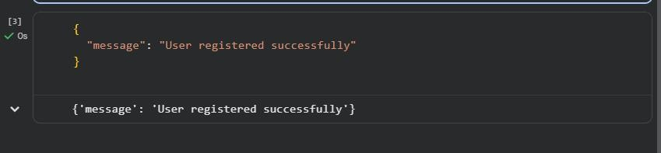

Output (Secure Version with Token):
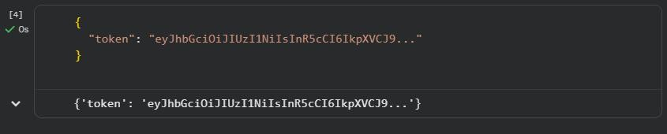

Task 2: Fair Decision Logic (Scholarship Eligibility)
Prompt: Generate a scholarship eligibility checker using academic score, family income, and location.

AI-Generated Code
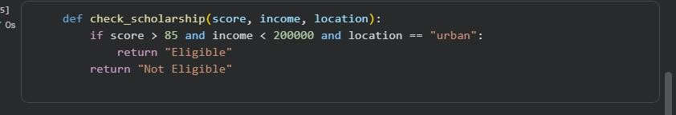

Fairness Issues Identified
- Unfairly favors urban students

- Rural or semi-urban students are disadvantaged
- Location should not be a strict condition

Improved Fair Logic
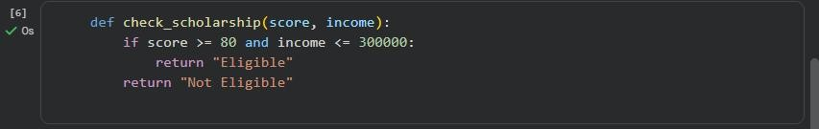

Explanation
The original logic unfairly favored urban students by using location as a strict condition.

This could disadvantage capable students from rural areas.

The revised logic removes location bias and focuses on merit and financial need. This ensures equitable and inclusive decision-making.
Output (Original Logic):

Output (Improved Fair Logic

Task 3: Explainability (Prime Number Check)

Prompt: Generate a function to check if a number is prime with comments and explanation.

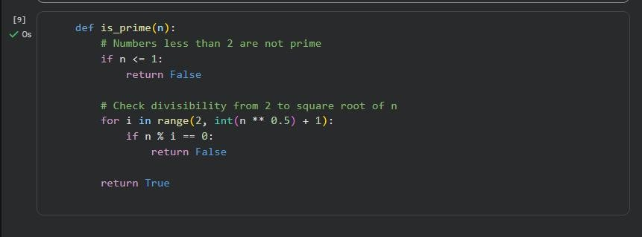

Explanation
- Numbers ≤ 1 are not prime

- Loop checks possible divisors efficiently

- Stops early to improve performance

Assessment of Explainability
- Code comments are clear and accurate

- Logic is easy to understand


- AI explanation improves transparency Sample Input

Output


Task 4: Ethical Scoring System (Employee Evaluation)

Prompt: Generate an employee performance evaluation system using project completion, teamwork, and attendance.

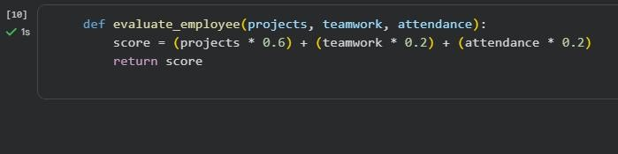

Ethical Analysis
- Project completion has very high weight

- Teamwork and attendance undervalued

- Could unfairly penalize collaborative roles

Balanced Scoring Code

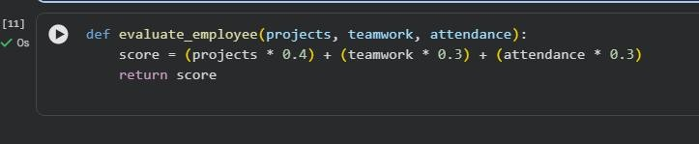

Explanation
The revised logic balances technical performance and teamwork. This avoids unethical bias toward only output-based evaluation. The criteria are more justifiable and fair.
Sample Input
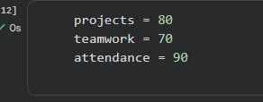

Output:


Output (Balanced Ethical Weighting)


Task 5: Accessibility and Inclusiveness (Feedback Form) Prompt : Generate a user feedback form application.
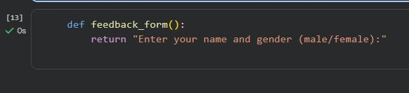

Issues Identified
- Gender options are restrictive

- Language is not inclusive

- Accessibility features missing Revised Inclusive Form Code
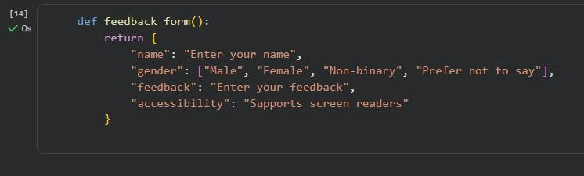

Explanation
- Uses inclusive language

- Avoids exclusionary assumptions

- Supports accessibility needs

Output
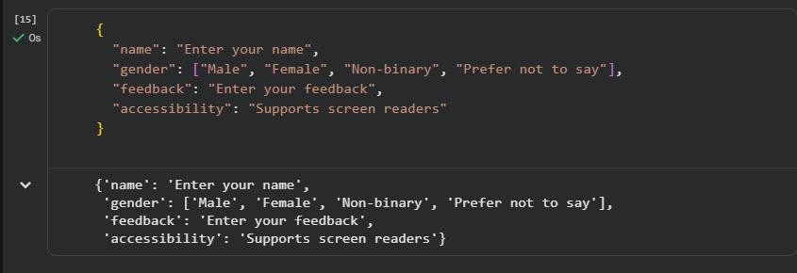

Final Conclusion
This lab highlights the importance of ethical responsibility in AI-assisted coding.
Developers must review AI-generated code for security flaws, bias, fairness, and inclusiveness.
Human oversight is essential to ensure transparency, accountability, and ethical software development.

